* What did you find? Which borough is the most expensive? Any other interesting trends?

Hackney is the most expensive London borough.

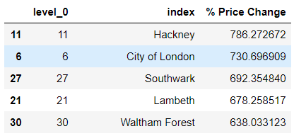

* How did you arrive at your conclusion?

By calculating the % price change from 1995 to present year (2020)

* What were the main challenges you encountered? How did you overcome them? What could you not overcome?
  + Plotting Bubble charts in Matplotlib
  + Use of lambda function.
  + Make code more concise by reducing number of variables
* Is there anything you’d like to investigate deeper?
  + Year -on-year change
  + Better plots